Experiment No: 04
Experiment Name: Managing Linux Processes and Monitoring System Performance
Theory: The build-essential package installs necessary development utilities properly. Linux systems rely on packages for software compilation. The nvim text editor creates practical source code. Programmers write standard C files using this tool. The gcc compiler builds binary files from source. The operating system creates an execution environment reliably. It translates source statements into readable machine instructions. A process is basically a program in execution. Programs turn active when loaded into main memory. The system call fork() creates a child process. A parent process executes concurrently with its child. Python scripts invoke kernel services using os modules. The kernel manages crucial processes and system resources. These essential components ensure correct computer program execution.
Commands and Output:
- gcc: The GNU C Compiler, commonly referred to as GCC, is a standard tool used to compile C programs into executable machine code. Running the default command gcc filename.c triggers the compilation process and creates an executable binary named a.out. If a specific name for the compiled output binary is preferred, the -o option can be included by executing gcc filename.c -o filename.
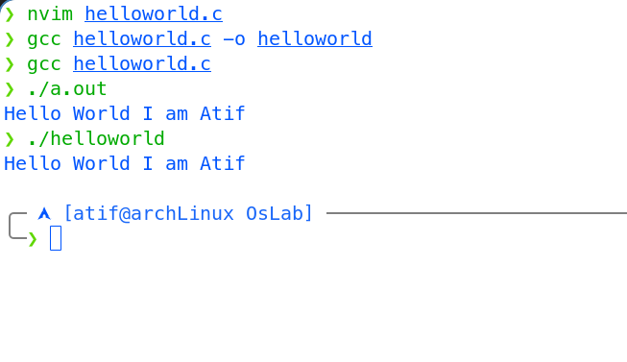

- Implementation of System Call:
The fork() system call generates a new process by cloning the existing caller:
- Parent Entity: The preexisting process that invokes the fork() operation.
- Child Entity: The newly spawned process which duplicates the parent's memory layout, runtime state, and open file descriptors.
A unique property of fork() is that it is invoked once but produces two separate return outcomes to separate the execution flow:
- Returns 0 in Child: Indicates that the currently executing flow belongs to the newly generated child process.
- Returns Child's PID in Parent: Delivers the child's unique process identifier to the parent for process monitoring and control.
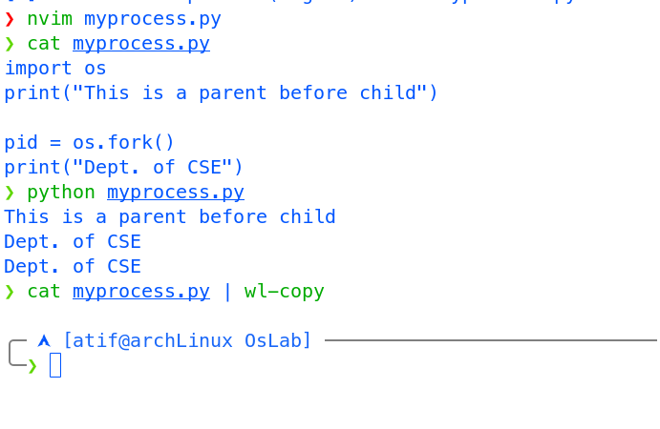

Breakdown:
- Before os.fork(): The initial single process (the parent) runs print("This is a parent before child"), producing the first output line.
- At os.fork(): The kernel duplicates the calling process into a new child process, creating two identical, concurrently running flows of control at that exact point in memory.
- After os.fork(): Both the parent and the newly created child continue execution immediately at the next instruction.
- Second Print: Because both processes execute print("Dept. of CSE"), the line is printed twice—once by the parent and once by the child.

Discussion:
This experiment provided practical insight into C program development and process management mechanisms within a Linux environment. By utilizing the GCC compiler, we observed the transformation of high-level source code into binary executables, exploring custom output generation using compiler flags. Furthermore, we explored process creation via the fork() system call using Python's os module. The execution demonstrated how fork() duplicates the parent address space into an independent child process, generating concurrent execution paths distinguishable by the returned PID values. Understanding process lifecycle events, return codes, and compiler operations is essential for mastering system programming and operating system resource management.

